**GOVERNMENT DEGREE COLLEGE, GUMMALAKSHMIPURAM**

**PARVATHIPURAM MANYAM**

**Name of the Event: International Day for Elimination of**

**Violence against Women**

**Guest of Honor : Dr. T. Sreevaram (Principal)**

**Date                : 25-11-2024**

**Organized           : Women Empowerment Cell**

**Lecturers Attended: 8**

**Students Attended: 110**

**Government Degree College Gummalakshmipuram women empowerment cell Coordinator Kum A.Srivani organised International Day for the elimination of violence against women. At this event Smt P.Prameela AHC counseling session under the president ship of Dr. T. Sreevaram principal of government degree college Gummalakshmipuram P. Prameela garu awareness students especially about the acts, such a dowry act, domestic violence ,Anti ragging women rights and proper child marriages act, pocso - sexual violence and harassment etc.**

**Nearly 110 students and staff participated and made the event     successful.**

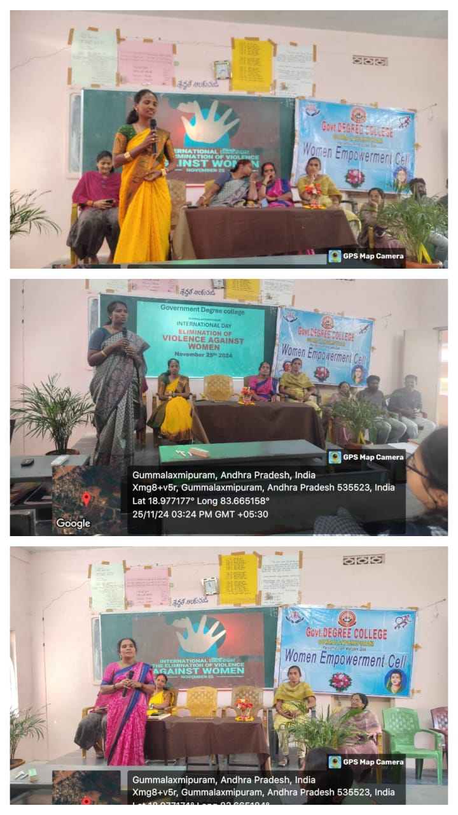

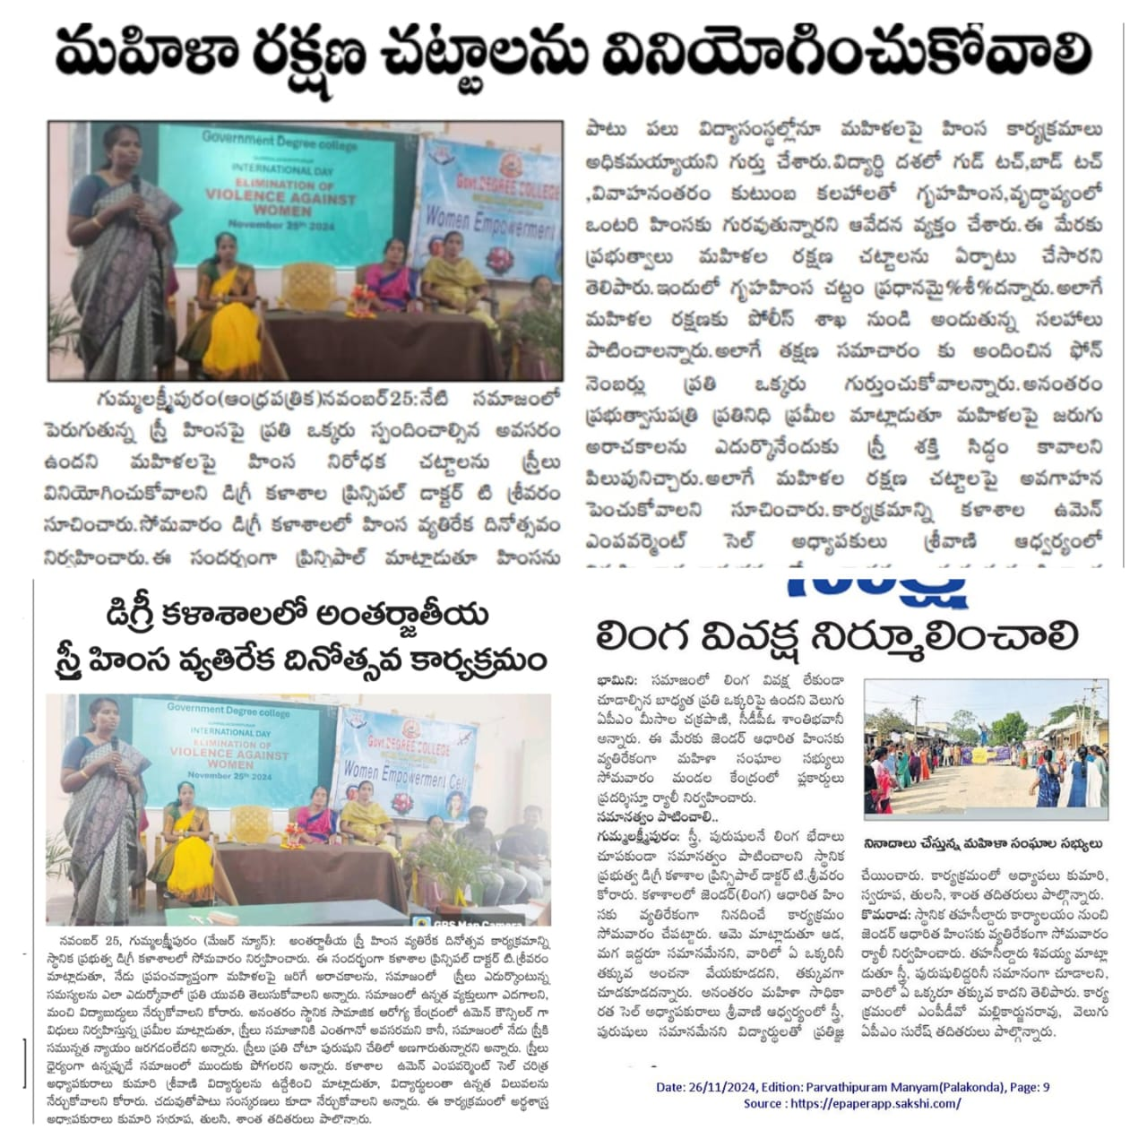

**Conclusion:**

**As we commemorate this day, let us not only remember the victims of gender-based violence but also commit ourselves to creating a world where no woman has to live in fear. Change starts with us—through our words, our actions, and our unwavering commitment to justice and equality.**

**Together, we can build a future where women and girls can live free from violence, with dignity, safety, and respect.**